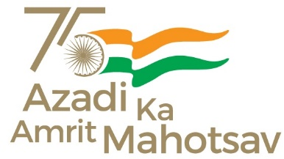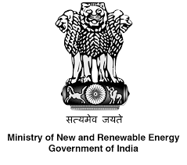

“NEW FRONTIERS: A Programme on Renewable Energy”
India’s leadership in Energy Transition
16th February 2022, Vigyan Bhawan
Concept Note
India has been a pioneer in the field of energy transition with facilitative Government policies and active participation and contribution from its private sector. Both the scale and pace of this transition have been impressive. This is evident from the fact that while India had committed to a target of achieving 40% non-fossil fuels based installed electricity capacity by 2030 at COP21, the milestone has been achieved nine years before 2030. India’s non-fossil fuels based installed electricity today stands at more than 158 GW. India has now raised its ambition and set for itself a target of 500 GW of non-fossil fuels based electricity capacity by 2030. The inaugural event for MNRE’s Azadi Ka Amrit Mahotsav programme will celebrate “India’s Leadership in Energy Transition”.
Hon’ble MoS, New and Renewable Energy will deliver the plenary address at the event and share his views about India’s energy transition ambitions, the progress made so far, the road ahead and ways to ensure greater participation of citizens in the transition.
The key highlight of the event will be the conversation of Hon’ble Minister, Power and NRE with students and representatives of industry regarding issues important for the energy transition and the way ahead.
India was designated a global champion for the energy transition theme of the UN High Level Dialogue on Energy convened in September 2021. One of the key outcomes of the dialogue was the submission of voluntary commitments on SDG-7 in the form of energy compacts by various stakeholders. Twenty two compacts were submitted to the UN by PSUs, Smart Cities and Corporates from India. These were in addition to the national energy compact submitted by the Ministry of New and Renewable Energy. The CMDs/CEOs of these twenty two organizations will be felicitated at the event.
The event will be widely publicized through print and broadcast media as well as on various social media platforms and will be supported by other relevant events to facilitate large scale “Jan-Bhagidari”.

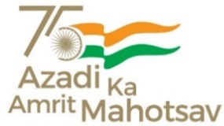

presents
New Frontiers: A Programme on Renewable Energy
India’s Leadership in Energy Transition

1500 – 1800 IST, Wednesday, 16 February 2022 | In-Person | Vigyan Bhawan, New Delhi*

AGENDA

1500 – 1510 | Welcome and setting the context  Shri Indu Shekhar Chaturvedi  Secretary, Ministry of New and Renewable Energy, Government of India
1510 – 1515 | Special address  Shri Alok Kumar  Secretary, Ministry of Power, Government of India
1515 – 1520 | Feature video  Citizen-Centric Energy Transition: The India Story
1520 – 1525 | Plenary address  Shri Bhagwanth Khuba  Hon'ble Minister of State for New and Renewable Energy & Chemicals and Fertilisers, India
1525 – 1620 | In conversation with  Shri Raj Kumar Singh  Hon'ble Union Cabinet Minister for Power, and New and Renewable Energy, India  Moderated by  Dr Arunabha Ghosh, Founder-CEO, Council on Energy, Environment and Water (CEEW)
1620 – 1630 | Feature video: CEOSpeak  India’s Energy Compacts: Leading the Global Energy Transition
1630 – 1655 | Energy Compacts (EC) felicitation and launch of EC Booklet by Hon’ble Ministers  Shri Raj Kumar Singh and Shri Bhagwanth Khuba
1655 – 1700 | Concluding remarks and vote of thanks  Shri Dinesh D Jagdale  Joint Secretary, Ministry of New and Renewable Energy, Government of India
1700 – 1800 | Tea/coffee, and close of session

